Практическая 3 Гладышева Анастасия Викторовна

ПР-22.106

**1 Задание:**

select substring ("X" from length ("X") - 9) as res

from "table_1"

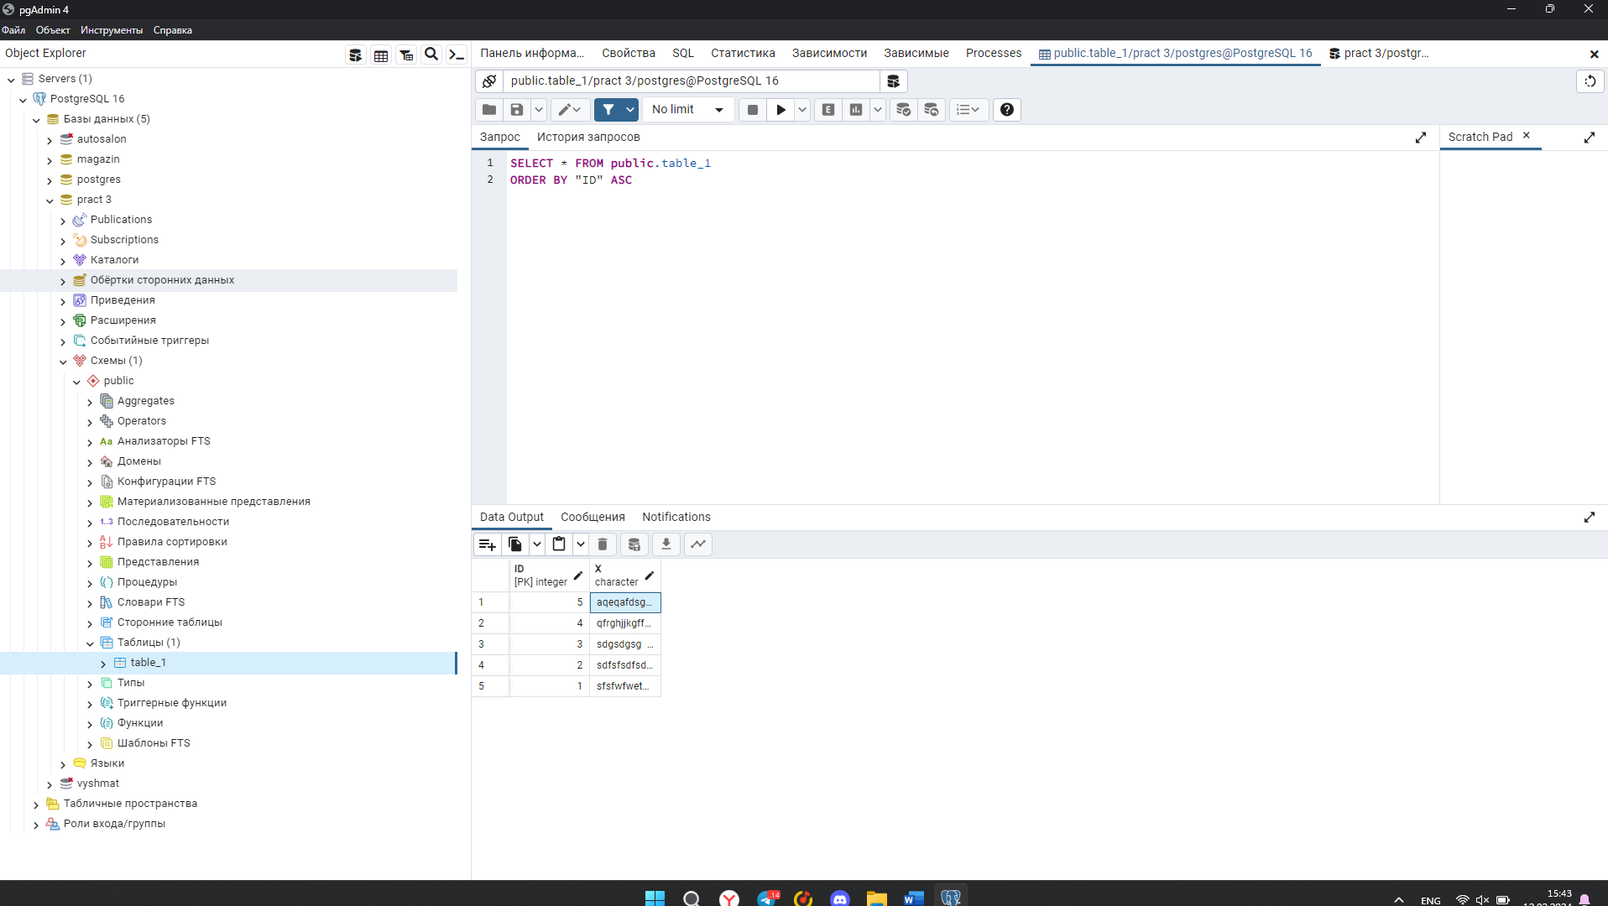

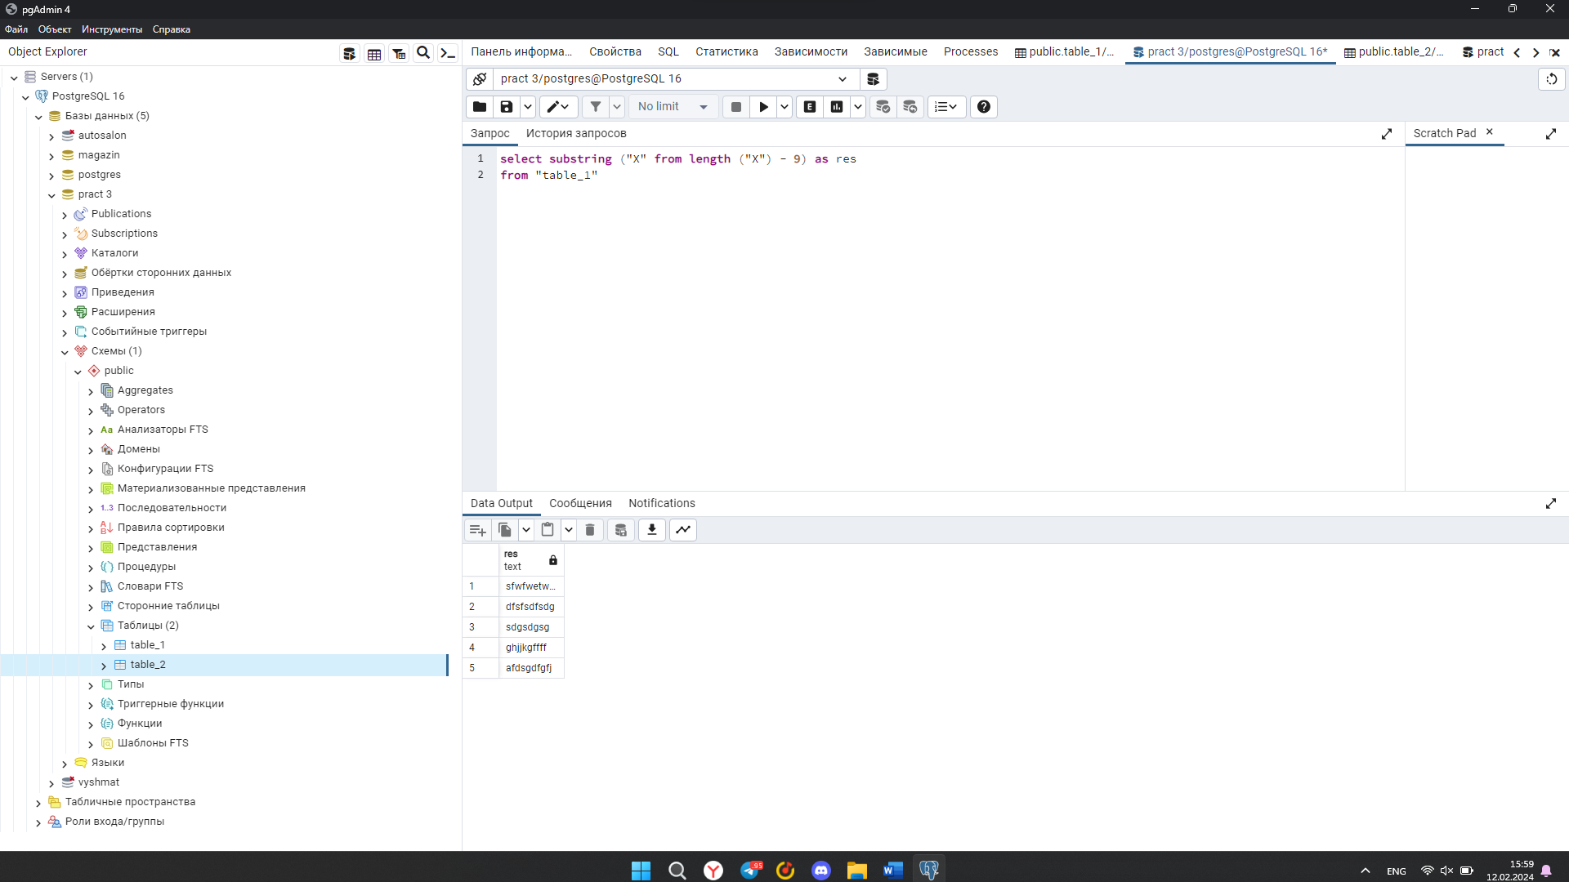

**2 задание:**

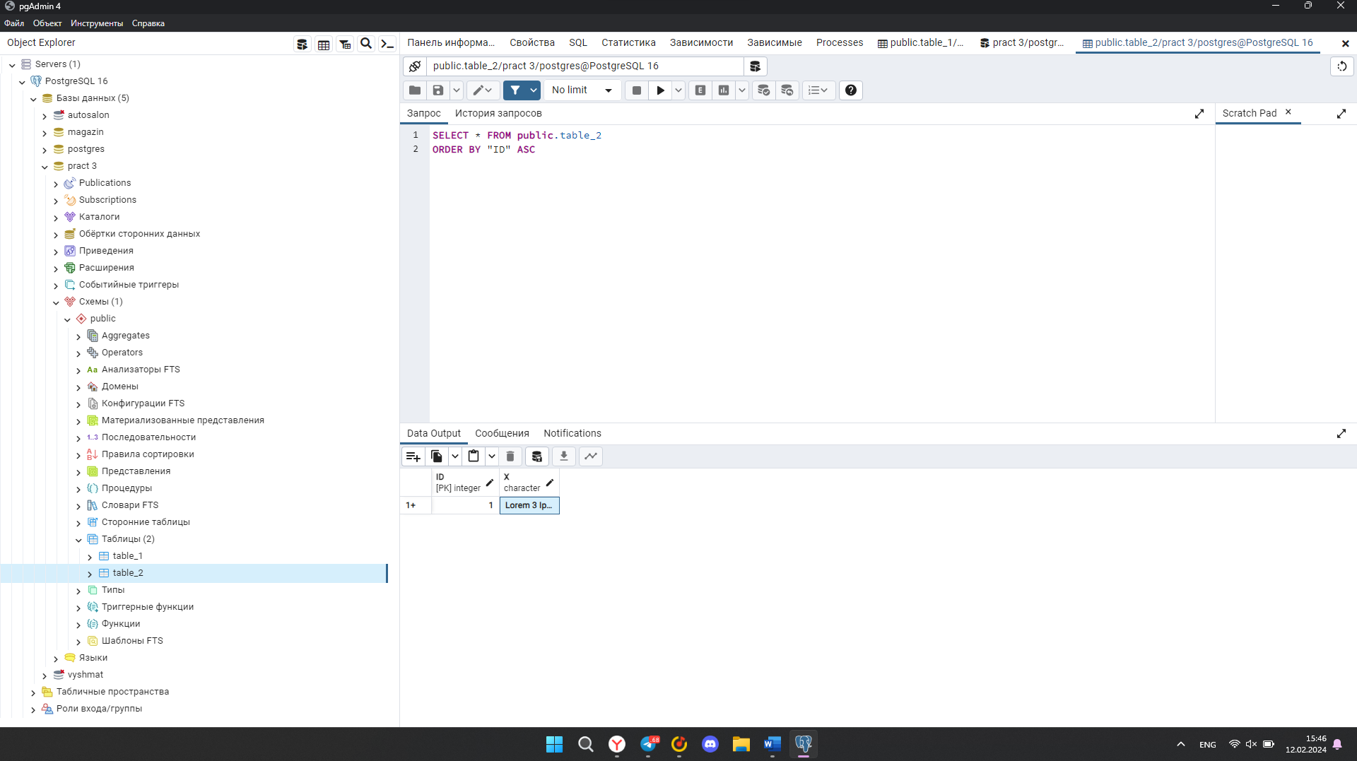

А) SELECT SUBSTRING("X" FROM 42 FOR 68) AS res

FROM "table_2";

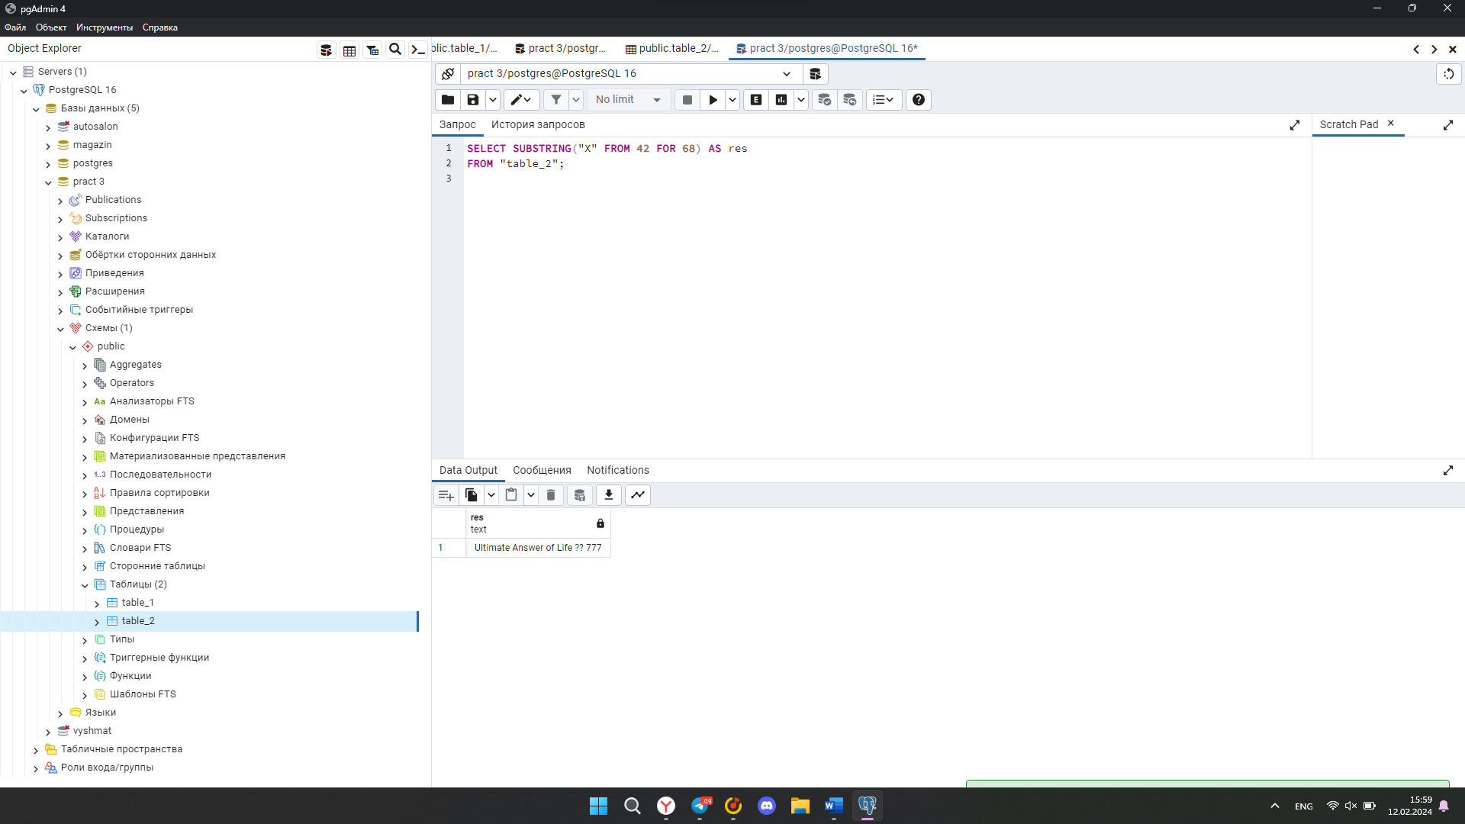

Б)

SELECT REGEXP_REPLACE("X", '[^A-ZА-Я]', '', 'g') AS res

FROM "table_2";

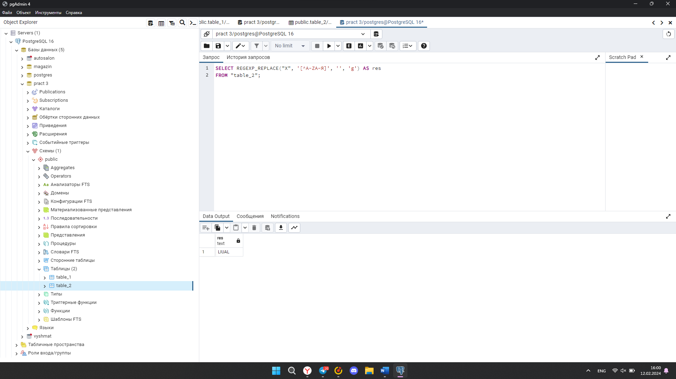

В)

SELECT SUM (CAST(regexp_replace("X", '\D', '','g') as integer)) as res

from "table_2"

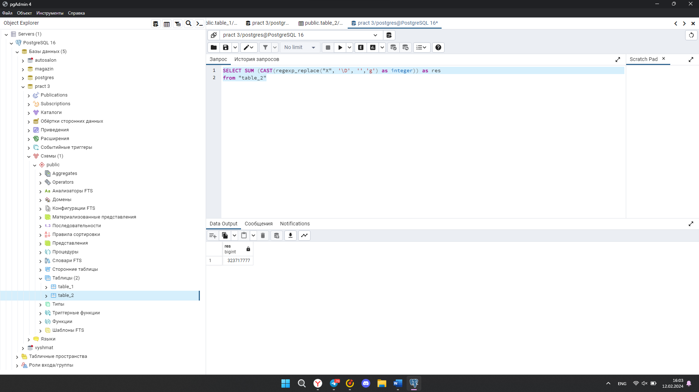

**Задание 3:**

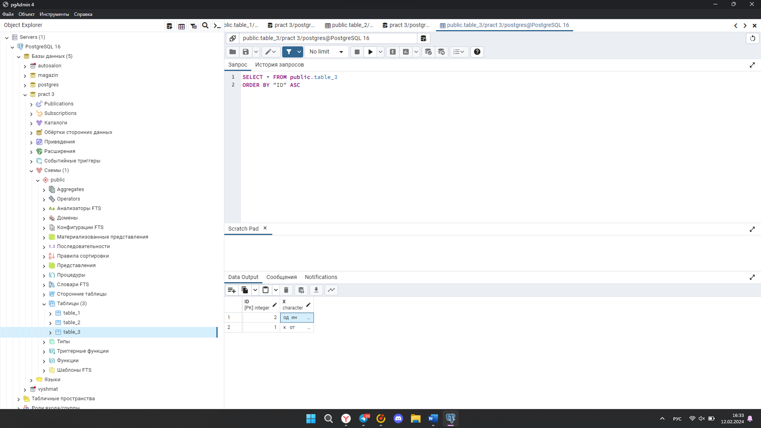

SELECT regexp_replace("X", '\s{2,}', ' ', 'g') AS res

FROM "table_3";

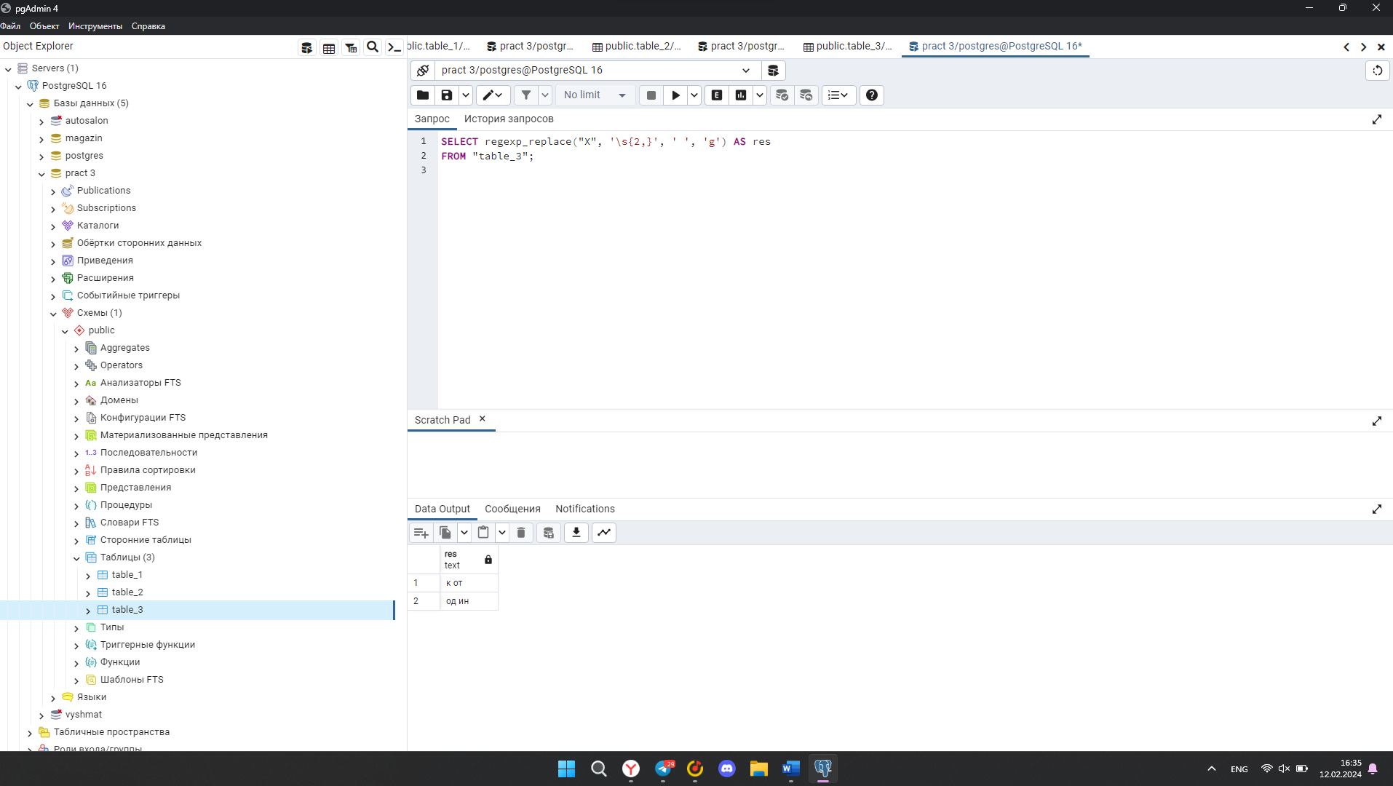

**Задание 4:**

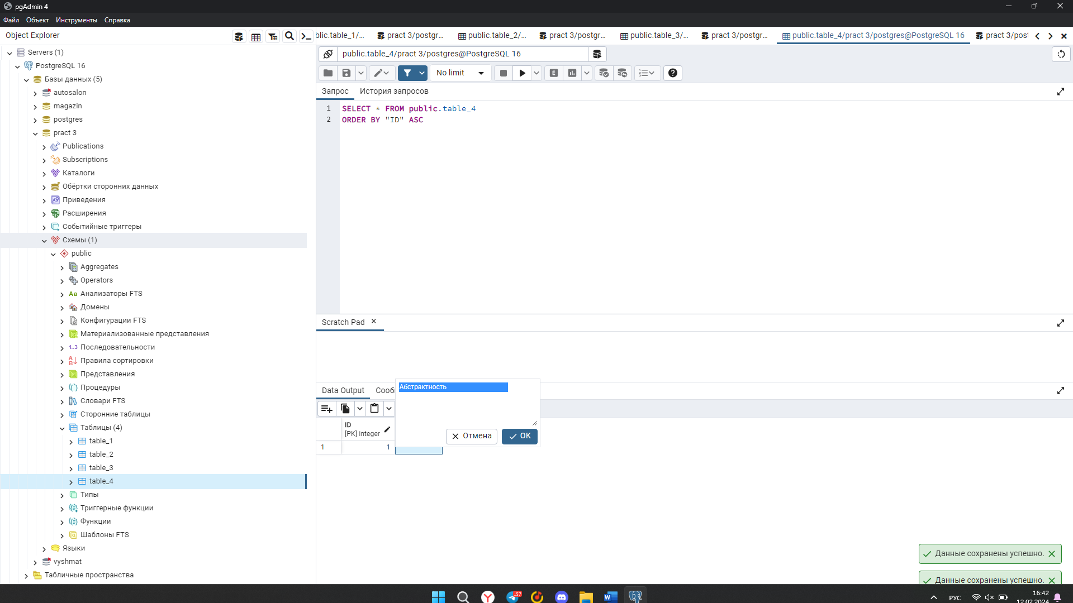

select translate ("X", 'Aaoc', 'Ааос') as res

from "table_4"

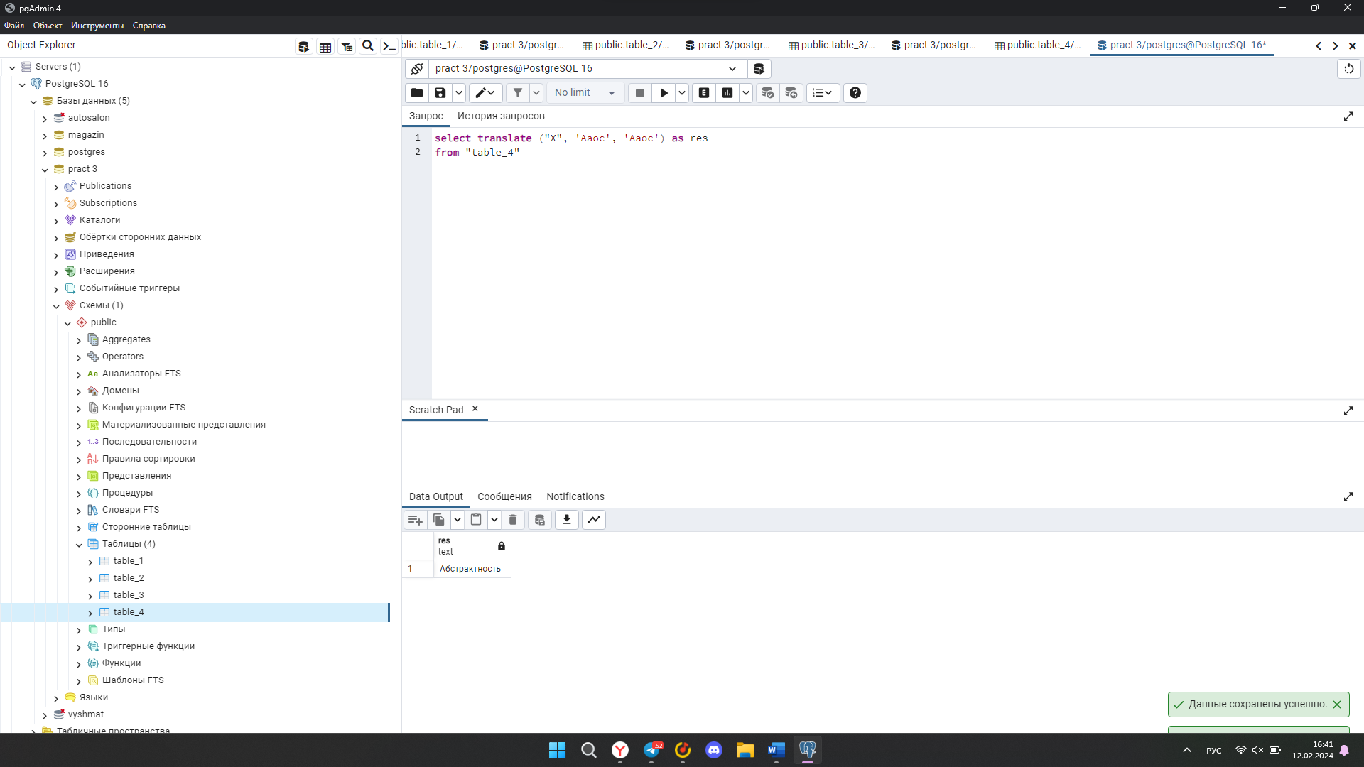

**Задание 5:**

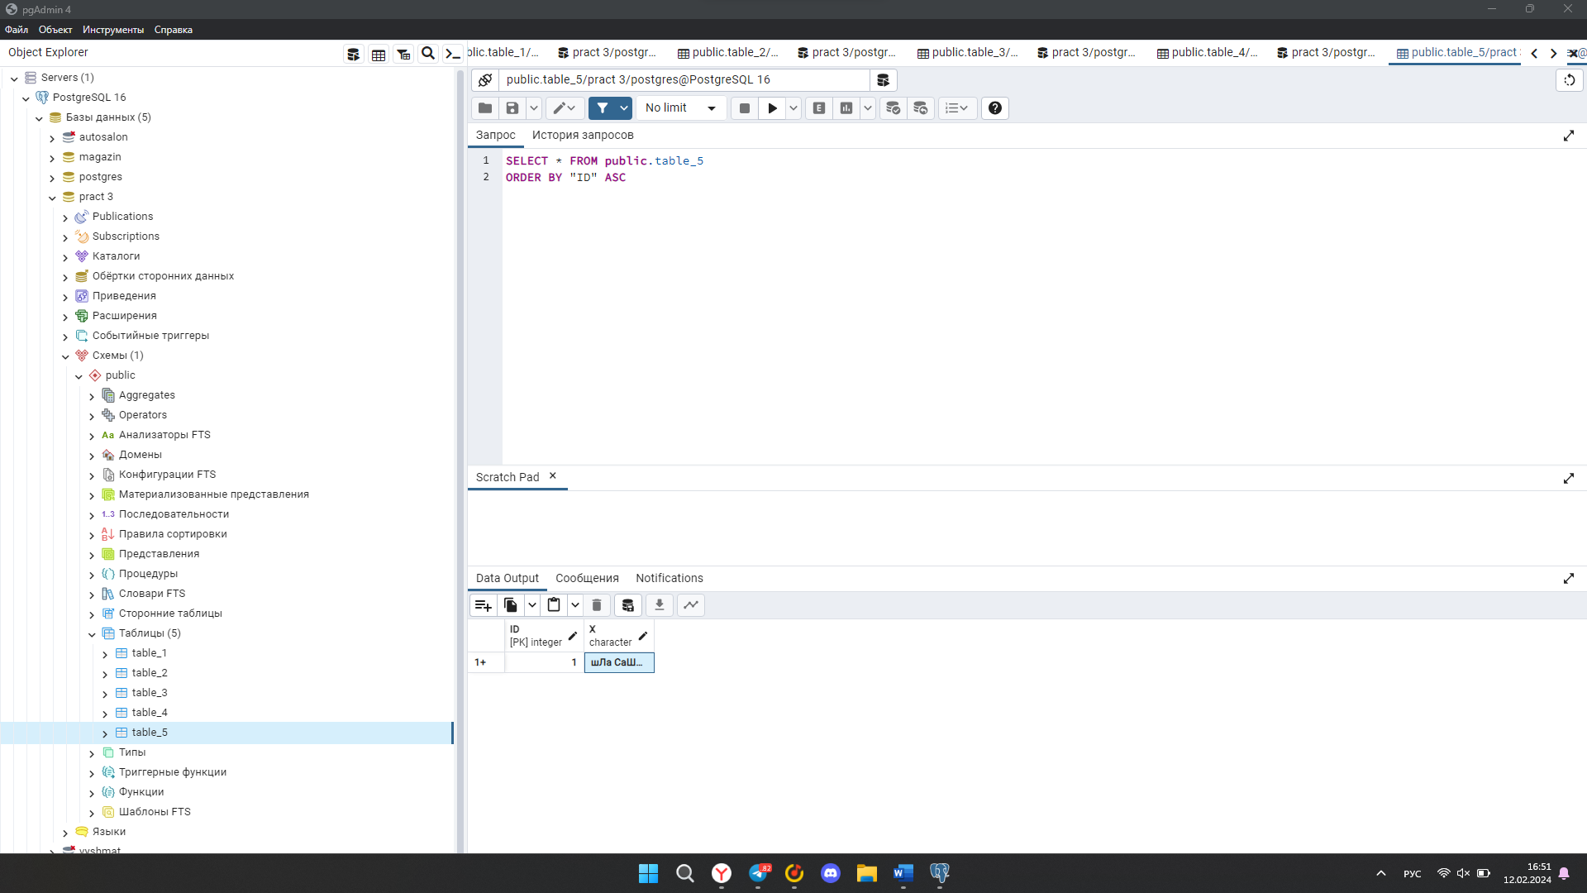

select initcap ("X") as res

from "table_5"

